Evidences:

Jira

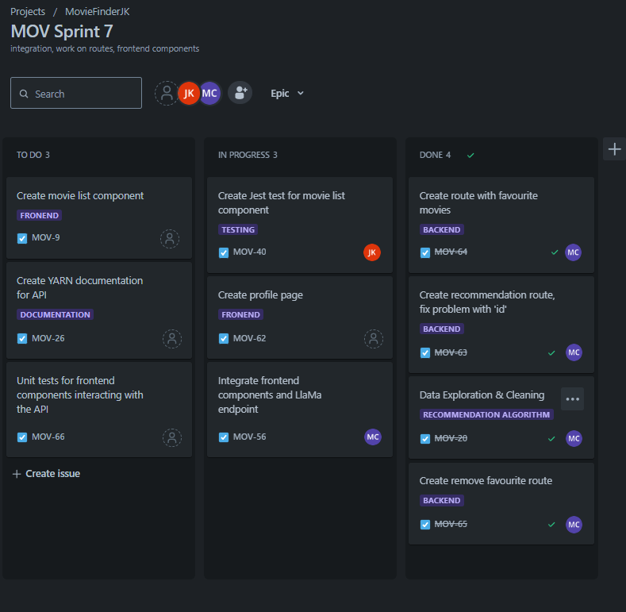

DoD

Sprint retrospectives

Roadmap

Bitbucket-pipelines

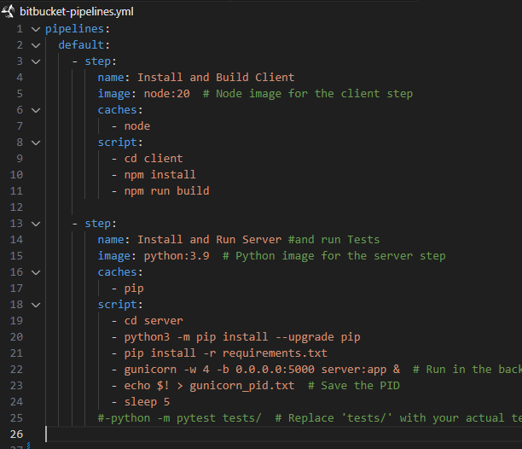

Jest test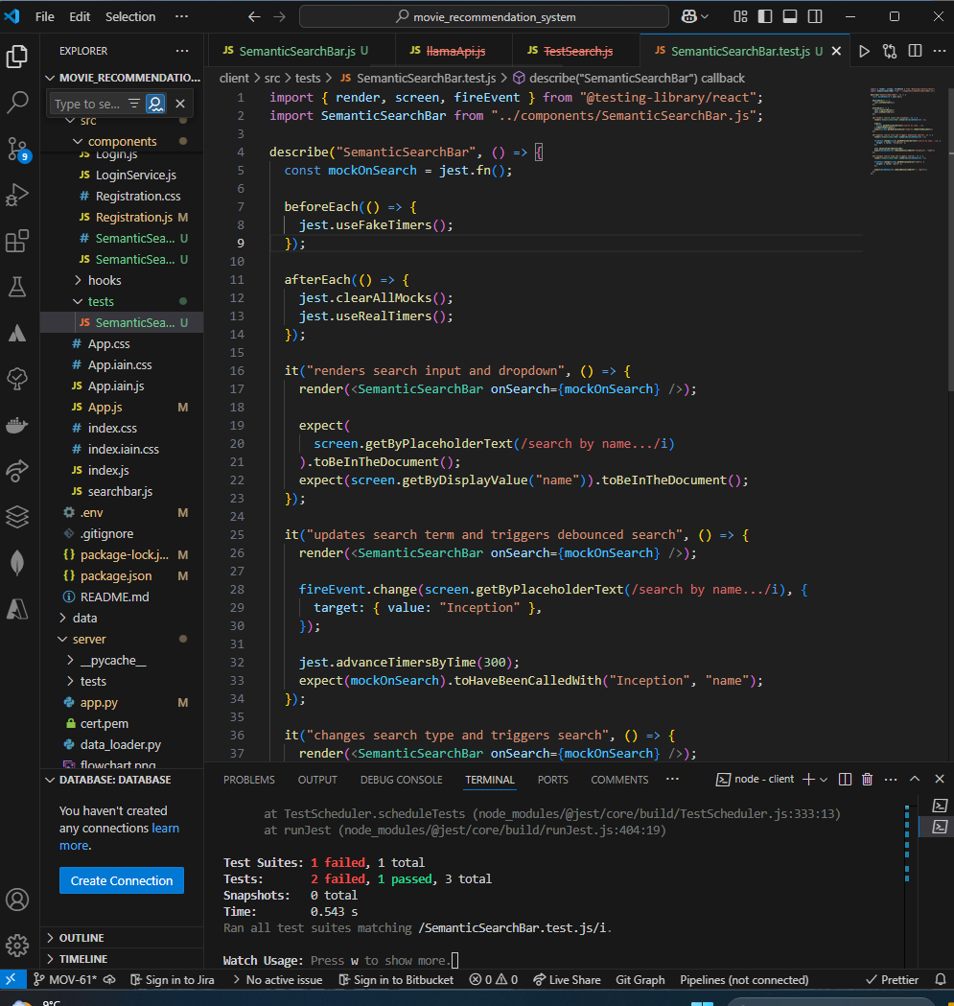

Flowchart

Pull Requests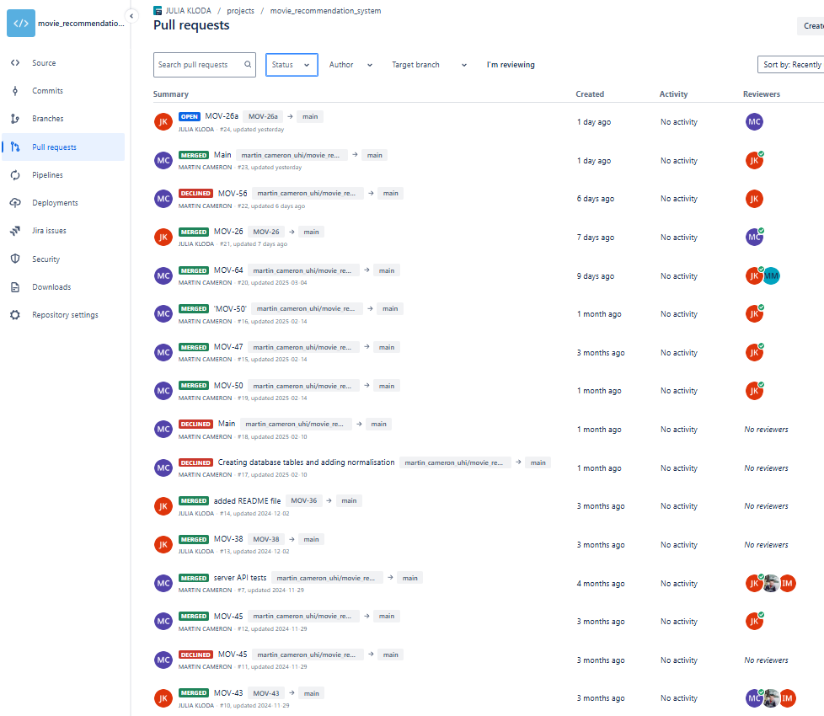Postman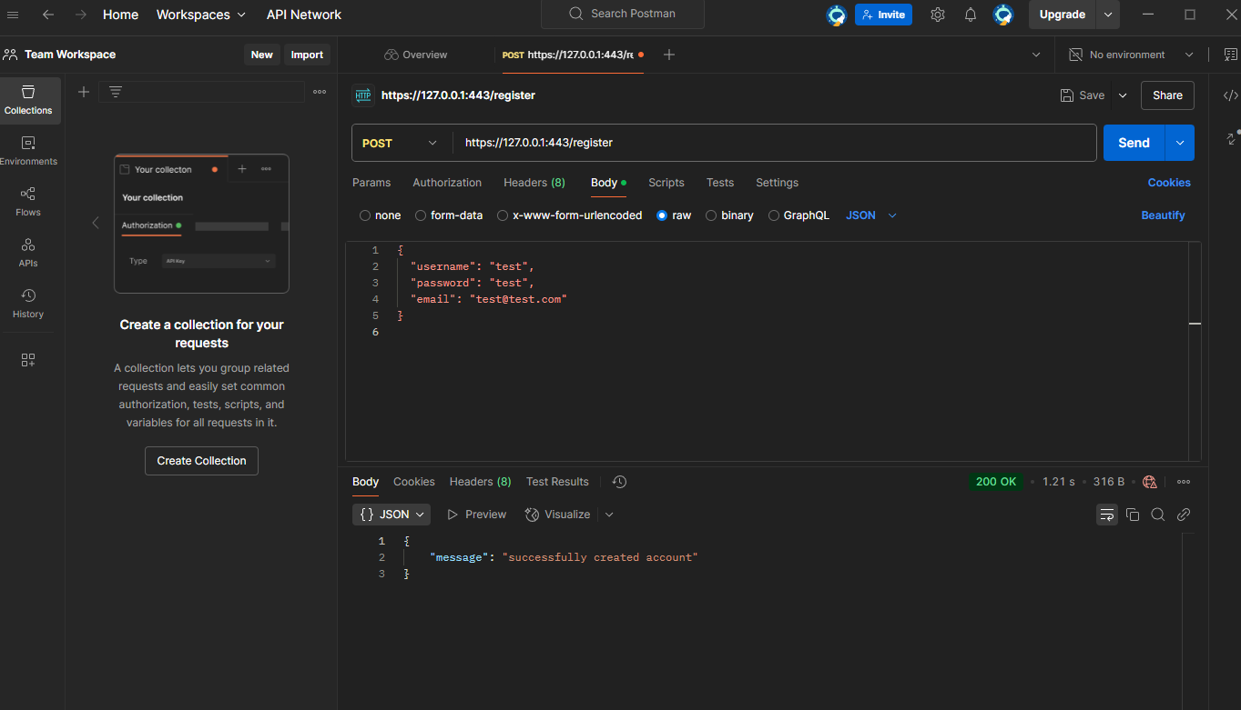

Encrypted data:

